**SPRING REST using Spring Boot 3 HANDSON**

**Hands on 1**

Create a Spring Web Project using Maven :

->

Step-1:Downloading the zip file from spring initializer

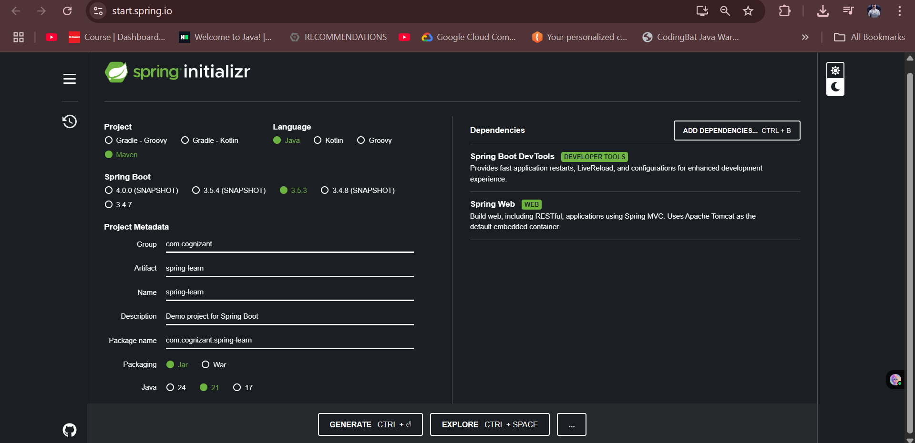

Step-2: Opening Command Prompt & Build the Project using Maven (with proxy)

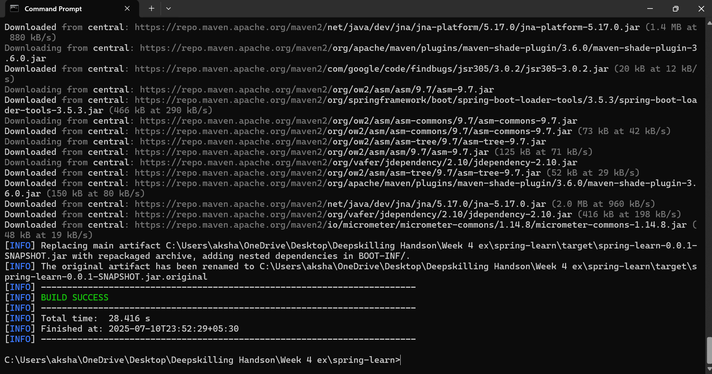

Step-3:Importing the Project in Eclipse

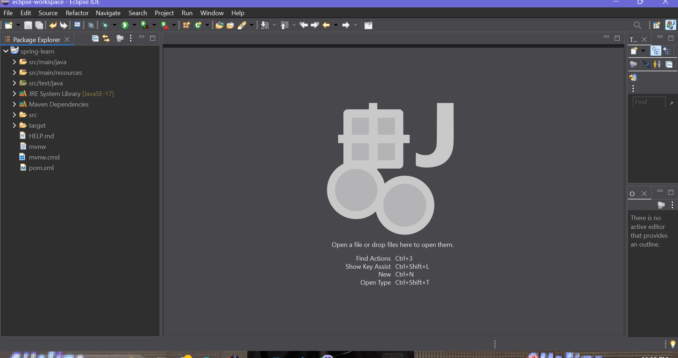

Step-4: Including Logs to Verify main() Method

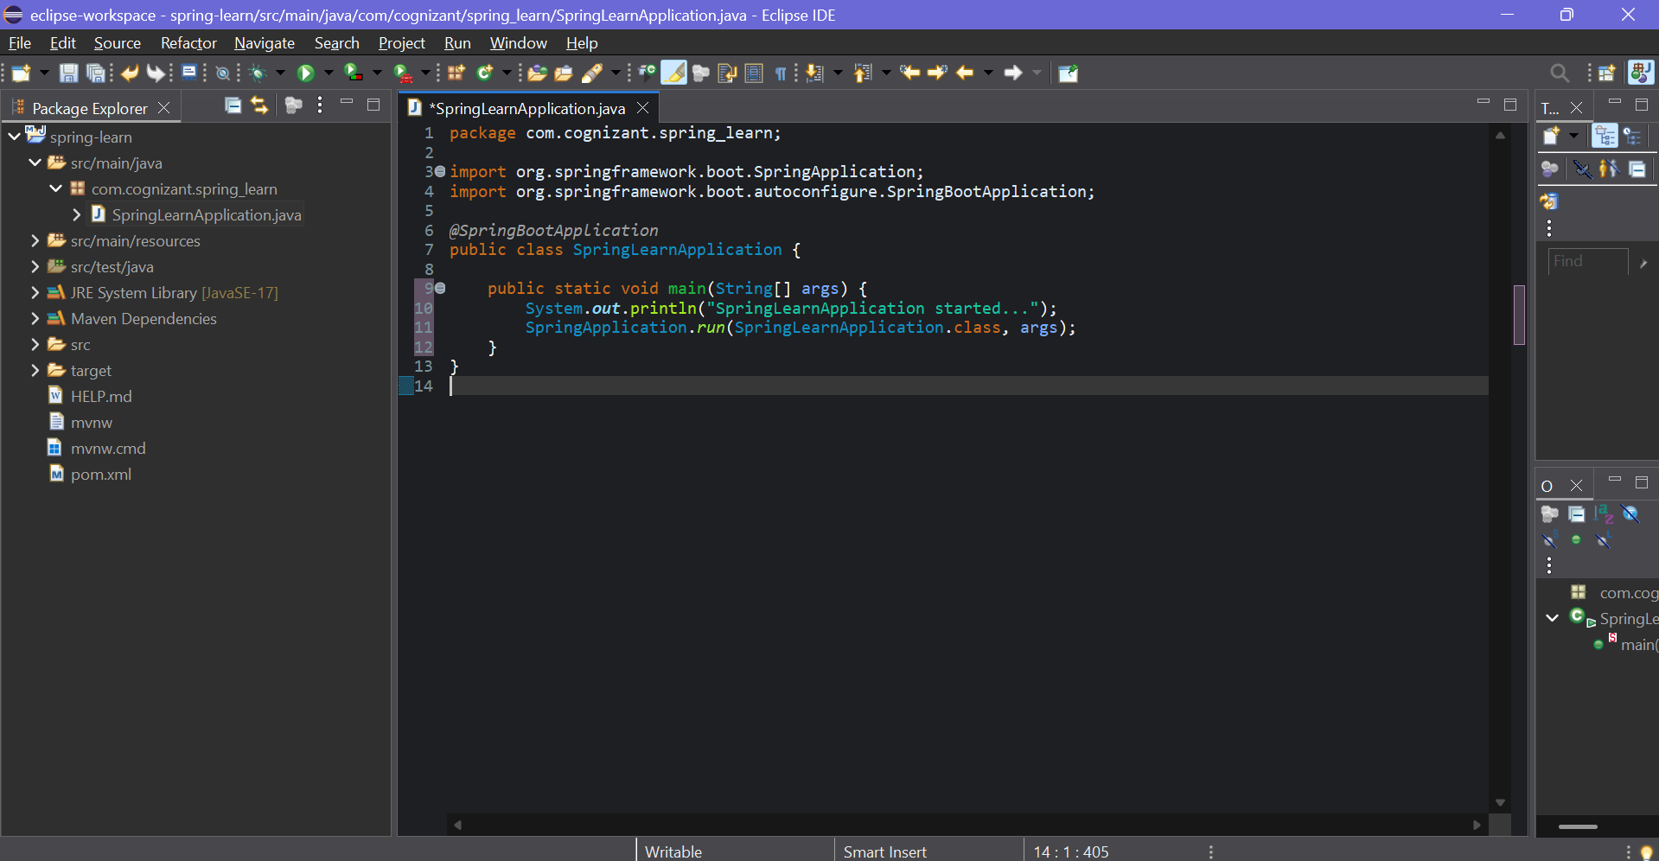

Step-5: Running the application

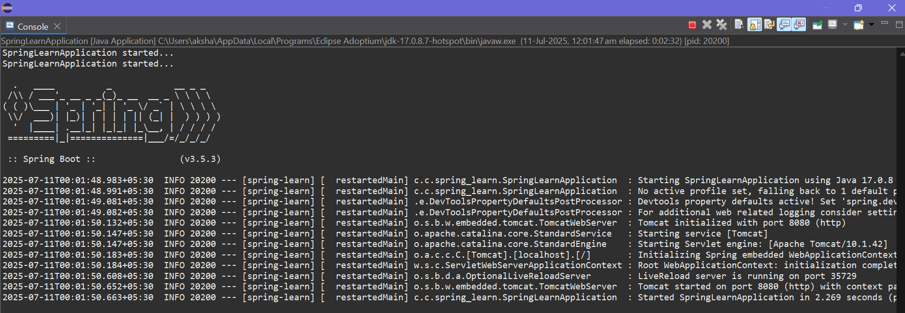

**Hands on 4**

Spring Core – Load Country from Spring Configuration XML:

->

Step-1:Creating the country class

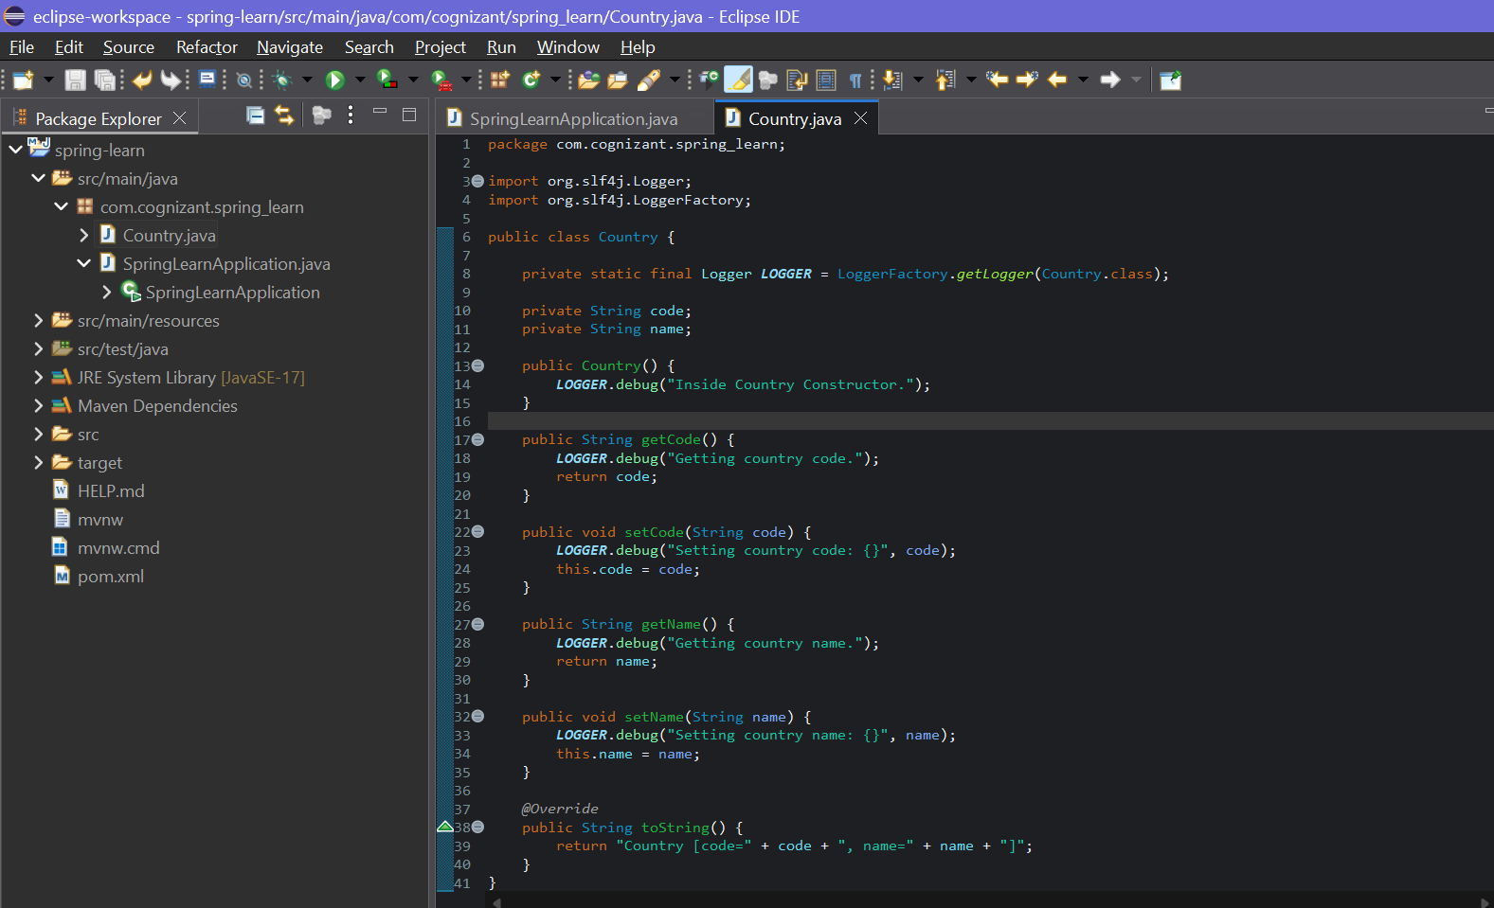

Step-2: Creating country.xml

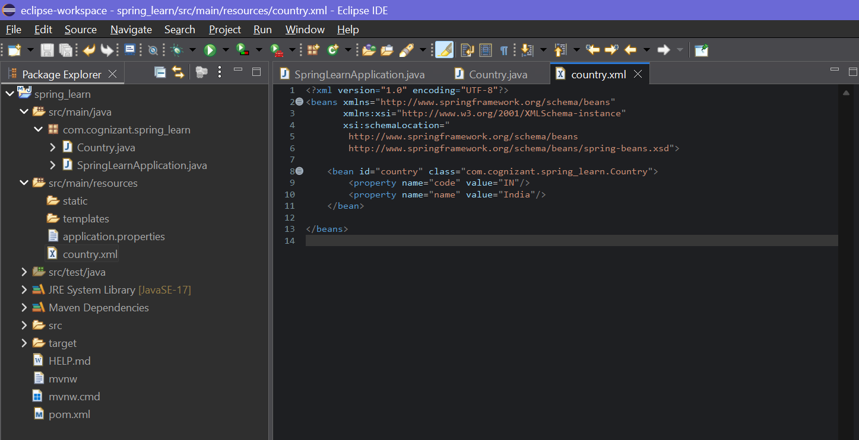

Step-3:Modifying SpringLearnApplication.java

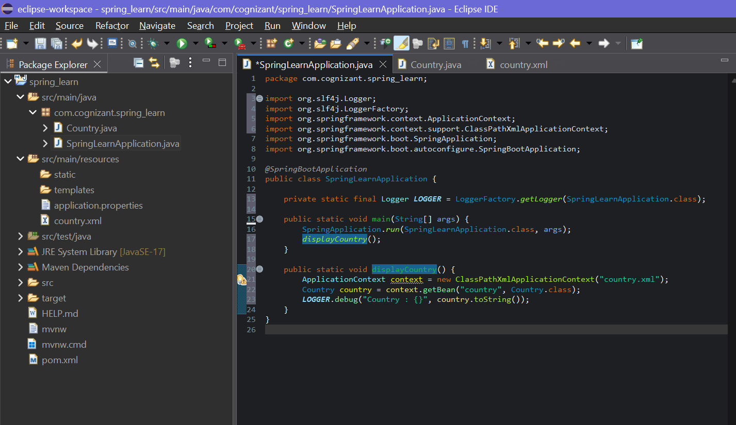

Step-3:Running the application(SpringLearnApplication.java)

Output->

